CST2550 Coursework 1
library manegemnt system
Hadas Cohen
Student ID:M00917628
January 15, 2024

INTRODUCTION
IMPLEMENTATION OF CODE:
I decied that its best to give the librarian the option to register/login and only after that part was verified they can add a member, issue a book, calculate fine , display borrowed books.
I also throught its best to have a librarian_data.txt file and member_data.txt file to store the libraraians and members and check wether the exist, if so they wont be stored twice.
Librarian functions:
addMember();
issueBook();
calcFine();
displayBorrowedBooks();
returnBook();
Member functions:
Book functions:
THINGS I WOULD DO DIFFRENTLY:
To begin, I would test the code after each additonal function that has been added to the code, my approch was wrong and took too much time and in that time that was waisted I could have made more tests to make my code more efficient.
OVERALL OUTCOME:
I belive that the OOP approche made everything easy to implement if I would have done things in the right manner from the beginging
ACTIVITY DIAGRAM:
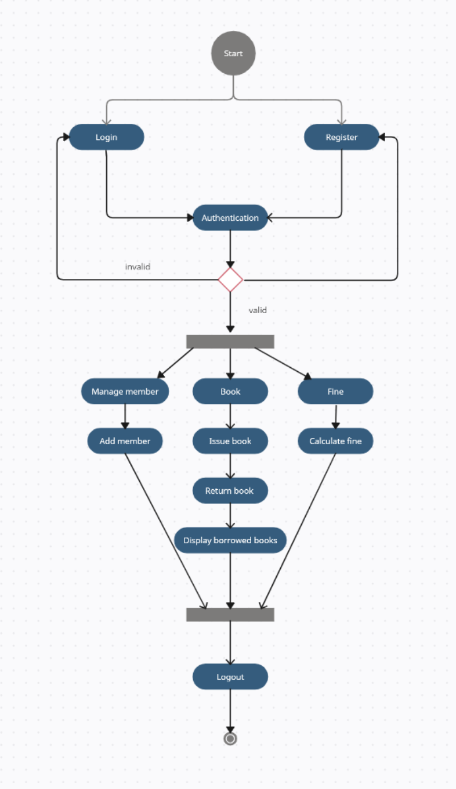

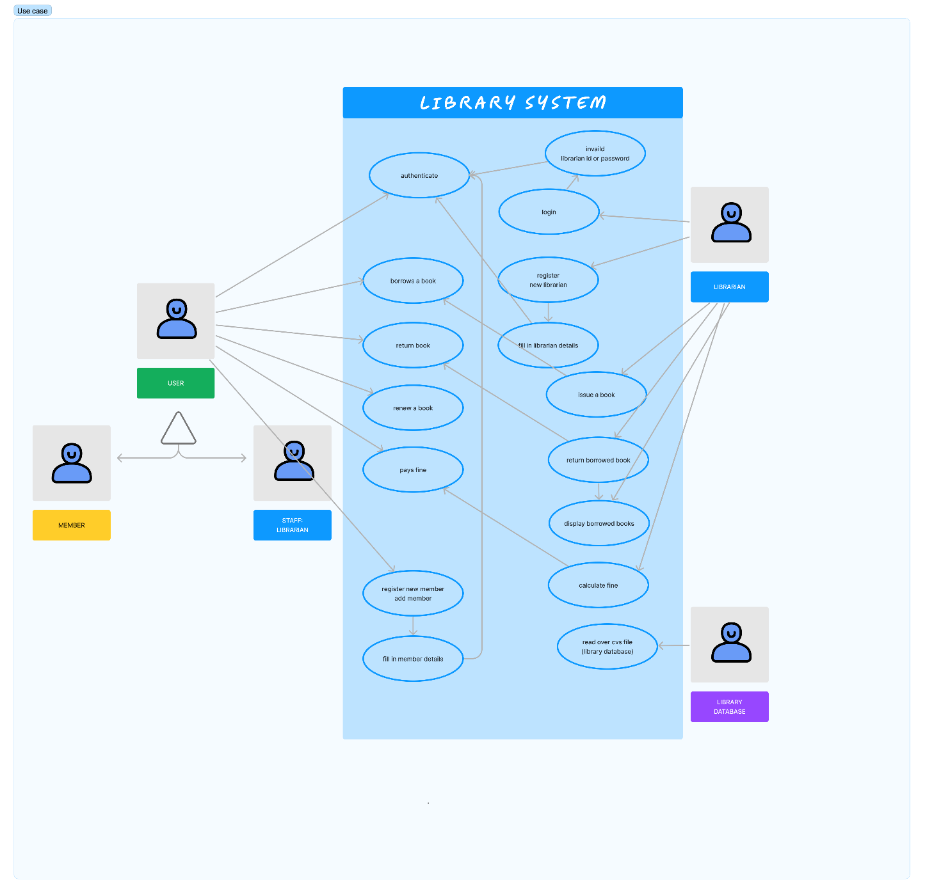
USE CAS DIAGRAM:
Person (User): in our program we have two users, librarian and member, they inherit from person. (like one of our example in lab shapes, we had a rectangle circle and ,they inherit from shapes class.
Some scenarios of the system are as follows :
- User who registers himself as a new user initially is regarded as staff - librarian or member for the library system.
- Librarian has a key role in this system. Librarian adds the records in the library database about each member every time issuing the book or returning the book, or paying fine.
  - For the librarian to get registered as a new user, registration forms are available that is needed to be fulfilled by the user.(error handing is taking place to check whether the user has entered the right input such as id in intType rather than a string.
  - After registration, the librarian will be given an option to
1.Register
2.Login: after the librarian has successfully logged in, the following options will apper:
1. Add member – The librarian adds a new member, after succesfully added the member details are saved onto member_data.txt, if two of the same members are added only one is stored.
2.Issue book - After, requesting, the desired book or the requested book is reserved by the user that means no other user can request for that book, the user can renew a book that means the user can get a new due date for the desired book if the user has renewed them there will be a fine included**.
3.Return nook – once a book is returned it becomes available for other members to borrow.
4.Display all borrowed books – printing the vector of all borrowed books.
5.Calculate fine – If the member somehow forgets to return the book before the due date (within 3 days), then the member pays fine, in the real world system we would also have a function that takes payment from member.
6.logout – the librarian has the option to logout and allow another librarian to login/register.

